In the name of God

University of Tehran

ECE School, Faculty of Engineering

Internship Report

# Loading operating system on a RISC-V processor

## Supervisor: Dr. Saeed Safari

Iman Rasouli Parto

810199425

# Introduction: This article is divided into two informative parts. In the first part, we delve into the process of modifying a Linux kernel, exploring the intricacies of this essential component of the operating system. The second part of this article guides you through the compilation of Linux on a RISC-V simulator, shedding light on this specialized task. Whether you're interested in understanding kernel customization or mastering the art of compiling Linux for RISC-V, this article has you covered.

Install and compile kernel on Linux Ubuntu

***Abstract***—***This article provides instructions for installing and compiling a new version of kernel in the Ubuntu distribution.***

***Keywords***—***module, Bootloader, kernel, compile, config menu***

Introduction: The Linux kernel is the main component of a [**Linux operating system (OS)**](https://www.redhat.com/en/topics/linux/what-is-linux) and is the core interface between a computer’s hardware and its processes. It communicates between the 2, managing resources as efficiently as possible.

The kernel is so named because—like a seed inside a hard shell—it exists within the OS and controls all the major functions of the hardware, whether it’s a phone, laptop, server, or any other kind of computer.

At the beginning, we need to update the system using the command below:

sudo apt update && sudo apt upgrade

Before compiling the kernel, we will need some required build tools. The following command will install them:

sudo apt install git fakeroot build-essential ncurses-dev libssl-dev bc flex libelf-dev bison dwarves

Now, we are ready to compile and install the kernel.

# Step 1: Download the source code

We can download the Linux kernel source code from [kernel.org](https://www.kernel.org/) website or use the command below (we’ll consider 6.1.39 version to install):

wget <https://cdn.kernel.org/pub/linux/kernel/v6.x/linux-6.1.39.tar.xz>

# Step 2: Extract the source code

Extract downloaded source code using the command below:

tar xvf linux-6.1.39.tar.xz

# Step 3: Configure kernel

After extracting the source code, navigate to the source directory:

cd linux-6.1.39

The configuration of kernel can be specified in a .config file. For this, we can use the config file of current kernel installed on OS:

cp -v /boot/config-$(uname -r) .config

This command used to copy current configuration of current system and not necessary if you are configuring a new system.

The terminal’s output would be like this:



Figure 1. Copy current kernel’s config file to new kernel directory

(The ‘uname’ -r command output is current version of system’s kernel.)

# Step 4: Build the kernel

Build the kernel using make command.

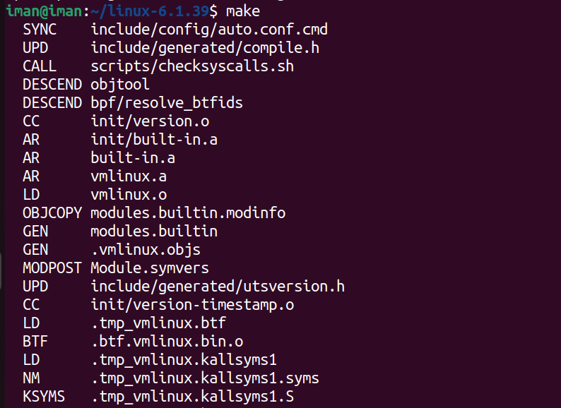

Figure 2. Compile and build the kernel

There will be some modules required. Install them with the command below:

sudo make install_modules

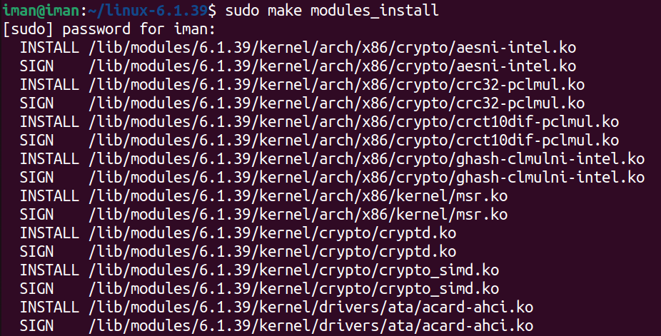

Figure 3. Installing kernel’s required modules

Then, install the kernel:

sudo make install

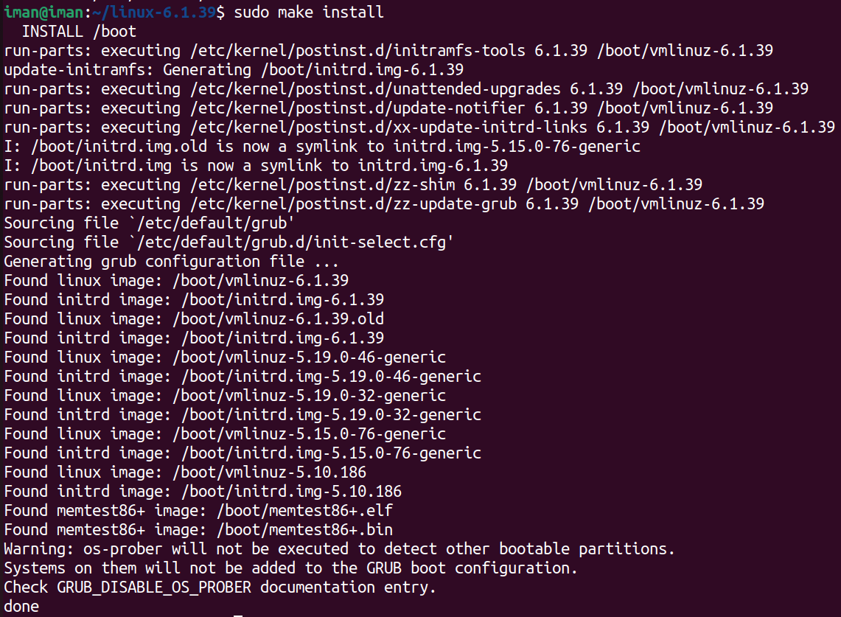

Figure 4. Installing the kernel

The output shows “**done**” when installing finished.

# Step 5: Update the Bootloader

The GRUB bootloader is the first program that runs when the system powers on. First update “initramfs” to the installed kernel version:

sudo update-initramfs -c -k 6.1.39



Figure 5. Update “inittramfs”

Then, update “GURB” bootloader:

sudo update-grub

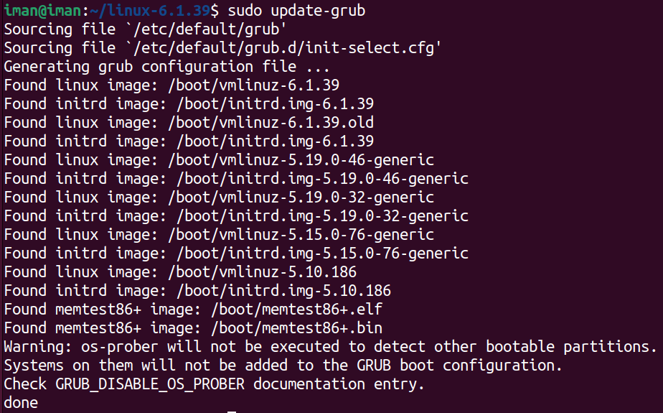

Figure 6. Update “GURB” bootloader

# Step6: Reboot and verify the kernel version

As we completed the steps above, reboot the machine. When the system boots up, verify the kernel version using ‘uname -r’ command.



Figure 7. Kernel’s new version has been installed

We can boot the system with different kernel version each time. If we hold the shift key when system boots up, the boot menu will load, and we can choose which kernel version boot the system with.

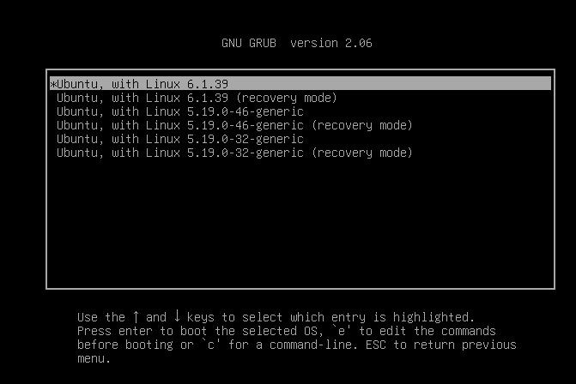

Figure 8. Boot menu shows all kernel version installed on the system

# Config menu

“menuconfig” is one of several configuration tools available for customizing the Linux kernel build options. It is a text-based configuration interface that allows users to select various kernel features, drivers, and settings.

make menuconfig

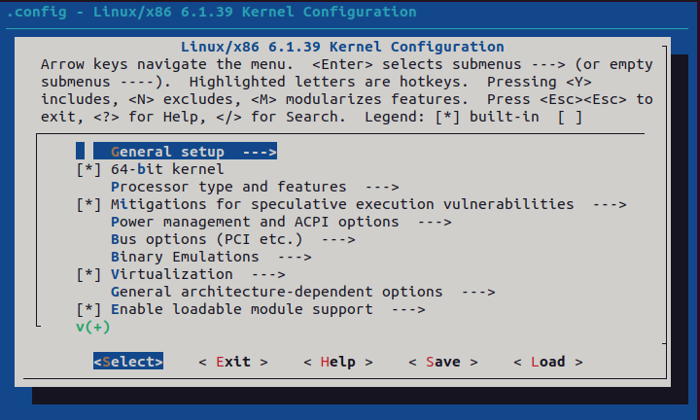

Figure 9. Kernel config menu

We can choose features in this menu to be compiled. If we navigate to “Device drivers”, we can see the list of drivers in the system, and we can choose whether to enable or disable each drive in the kernel.

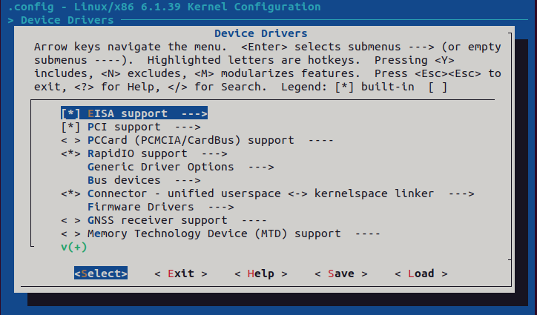

Figure 10. List of drivers in system

There are some symbols to activate or deactivate the drivers:

1. **[ ]**, **[*]**: Options in square brackets can be activated or deactivated. The asterisk marks the menu entry as activated. The value can be changed with the space key. It is also possible to press Y key (**Y**es) to activate or N key (**N**o) to deactivate the selected entry.

2. **< >**, **<M>, <*>**: Options in angle brackets can be activated or deactivated, but also activated as module (indicated by a *M*). The values can be modified by pressing Y/N keys as before or by pressing the M key to activate the feature/driver as a module.

3. **{M}**, **{*}**: Options in curly brackets can be activated or activated as module but not be deactivated. This happens because another feature/driver is dependent on this feature.

4. **-M-**, **-*-**: Options between hyphens are activated in the shown way by another feature/driver. There is no choice.

If we search for a module name (for example, Bluetooth module), the menu would jump straight to the option “*Bluetooth device drivers*”in the menu structure.

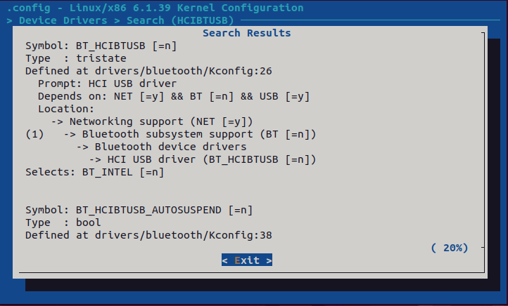

Figure 11. Bluetooth device (search using “HCIBTUSB”)

After configuring the kernel and quitting “menuconfig” it will save as “. /config”. The “. /config” file is a plain text file used to store the configuration options for the Linux kernel. “menuconfig” can also be launched using a text editor such as “code” using the following command:

code ./config

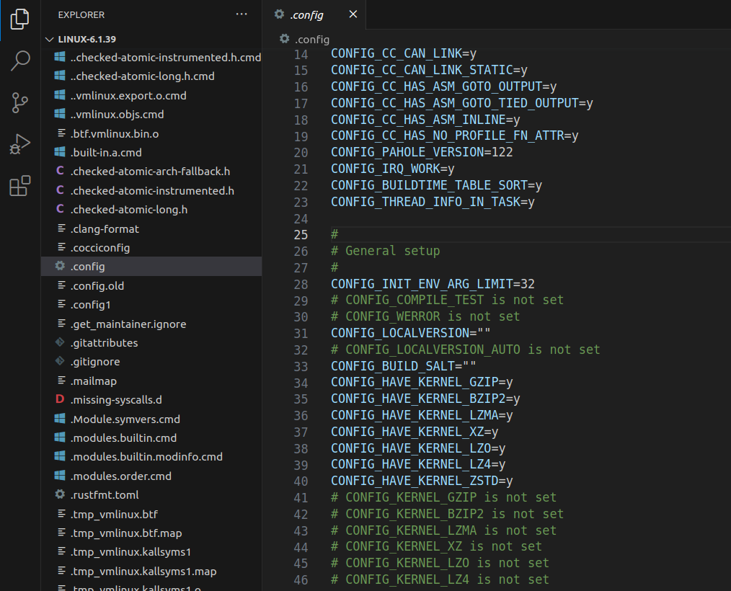

Figure 12. Open “menuconfig” with vs code

As shown in Figure 12, we can change the configuration here. For example, we can modify the activation of “xz” module on line 37 (change y to n).

There are some config keys, every key is connected to a C code by the Kconfig file. When we want to add a C code to kernel then we should create a Config key and define it for a C or directory of code.

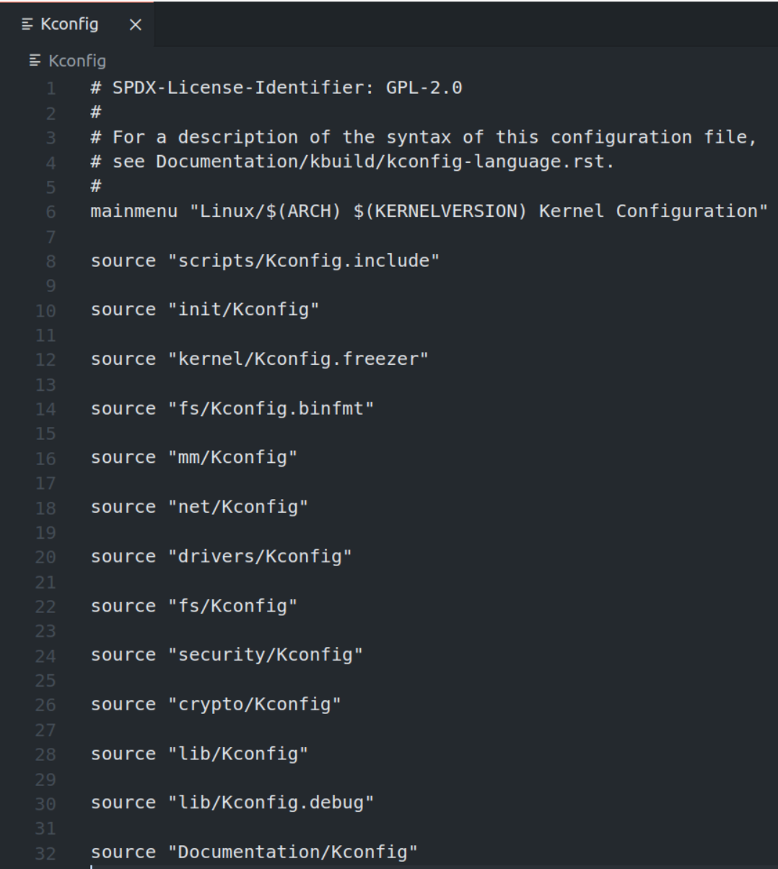

Figure 13. Kconfig file format

Kconfig file is a plain text file that’s readable and we can customize the kernel to be installed.

# Appendix

A list of installed packages required to compile the kernel is provided:

* git: Tracks and makes a record of all changes during development in the source code. It also allows reverting the changes.
* fakeroot: Creates the fake root environment. Used to see the errors while running the command.
* build-essential: Installs development tools such as [C](https://phoenixnap.com/glossary/c-programming-language), [C++](https://phoenixnap.com/glossary/c-plus-plus-programming-language), gcc, and g++ (C, C++ compilers).
* ncurses-dev: Provides API[1] for the text-based terminals.
* libssl-dev: Supports [**SSL** and **TL**](https://phoenixnap.com/kb/tls-vs-ssl)**S** that encrypt data and make the internet connection secure.
* bc (Basic Calculator): Supports the interactive execution of statements.
* flex (Fast Lexical Analyzer Generator): Generates lexical analyzers that convert characters into tokens.
* libelf-dev: Provides a shared library for managing ELF files (executable files, core dumps and object code).
* bison: Converts grammar description to a C program.
* dwarves: A set of tools that use debugging information inserted in ELF binaries by compilers such as gcc, used by well-known debuggers such as gdb, and more recent ones such as systemtap.

# References

[1] *Linux Kernel Programming (Kaiwan N Billimoria)*

[2] <https://www.redhat.com/en/topics/linux/what-is-the-linux-kernel>

[3] <https://phoenixnap.com/kb/build-linux-kernel>

[4] <https://davidaugustat.com/linux/how-to-compile-linux-kernel-on-ubuntu>

[5] <https://yum-info.contradodigital.com/view-package/epel/dwarves/>

[6] <https://wiki.gentoo.org/wiki/Kernel/Configuration>

[7] <https://linuxconfig.org/in-depth-howto-on-linux-kernel-configuration>

Compile Linux on RISC-V processor

***Abstract***—***This article provides instructions for compiling 64-bit Linux on RISC-V processor and test the program.***

***Keywords***—***config, make, Makefile, RISC-V toolchain, GCC***

Introduction: In embedded systems, the operating system (OS) communicates with the processor, manages resources, executes programs and performs other tasks. Therefore, understanding how an operating system compiles on a processor is essential. To test this process, a RISC-V processor is a suitable choice as it provides the appropriate tools for the task. In this article we are going to compile Linux on Spike simulator for RISC-V processor.

At the beginning, we need to update the system using the command below:

$ sudo apt update && sudo apt upgrade

Before compiling the Linux, we will need some required build tools. The following command will install them:

$ sudo apt-get install device-tree-compiler autoconf automake autotools-dev curl libmpc-dev \ libmpfr-dev libgmp-dev gawk build-essential bison flex texinfo gperf libtool patchutils bc zlib1g-dev \ libexpat-dev python2-dev python3-dev unzip libglib2.0-dev libpixman-1-dev git rsync wget cpio \ libncurses-dev

# Step 1: Get the simple repository from git

$ git clone <https://github.com/riscv-zju/riscv-rss-sdk.git>

Then, go to the directory and run quickstart:

$ sh quickstart.sh

After that, fetch all the system dependencies for the code:

$ git submodule update --init --recursive --progress

# Step 2: Set the RISC-V director as a variable and add it to PATH

$ export RISCV=/home/(your username)/riscv-rss-sdk

$ export PATH=$PATH:$RISCV/bin

Note: Replace “your_username” with your actual username. Be sure to use your own username in place of “your_username” to avoid any confusion.

Variables will be lost after a reboot. To prevent them from being lost after a reboot, open the “bashrc” file using a text editor and add these two commands to it. Make sure you are in your home directory.

$ gedit .bashrc

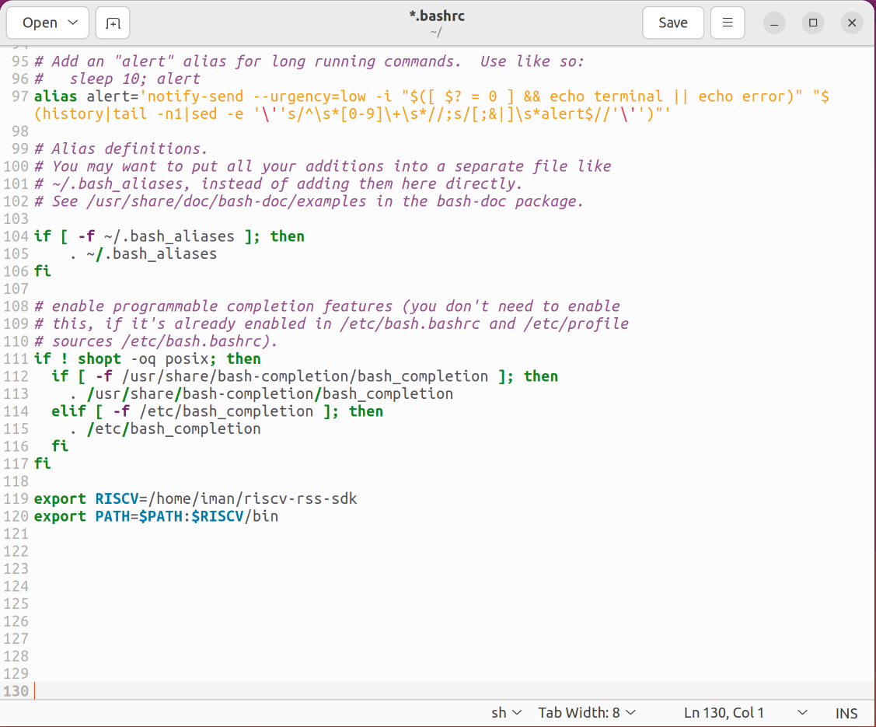

Figure 1. Add variables in bashrc file

Finally, save the file and exit.

# Step 3: Cross compile toolchain

$ cd $RISCV/repo/riscv-gnu-toolchain/

$ mkdir build && cd build

$ ../configure --prefix=$RISCV --with-arch=rv64imafdc --with-abi=ilp64d

$ make

The process will take some time.

Note: **Do not** execute any command with root access (don’t use “sudo”). It could fail the process.

Once the compilation is complete, the GCC compiler will be installed. You can find GCC compiler and its libraries in the “RISCV” and “RISCV/bin” directories. Commands that start with “riscv64-unknown-elf-” are used for cross-compile for the RISC-V processor. In addition, we need to cross compile GCC for Linux kernel with the command below:

$ make linux

After compilation, the compiler for Linux will be appear in “RISCV/bin” directory with start in name “riscv64-unknown-linux-gnu-”. Now you have all tools for compile all we need for simulations.

# Step 4: Build the Proxy kernel

Execute following instructions to build the Proxy kernel:

$ cd $RISCV/repo/riscv-pk

$ mkdir build && cd build

$ ../configure --prefix=$RISCV --host=riscv64-unknown-elf

$ make

$ make install

# Step 5: Build Spike simulator

Execute following commands to compile Spike:

$ cd $RISCV/repo/riscv-pk

$ mkdir build && cd build

$ ../configure --prefix=$RISCV --enable-histogram

$ make

$ make install

# Step 6: Verify the simulator

To verify the compilation, run this simple code with the commands:

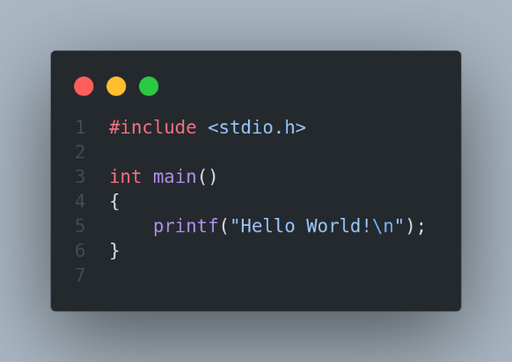

$ riscv64-unknown-elf-gcc test.c

$ $RISCV/repo/riscv-isa-sim/build/spike --isa=RV64I $RISCV/repo/riscv-pk/build/pk a.out

If “Hello world!” appeared in the terminal it’s mean you have everything for compilation and simulations for linux kernel.

# Step 7: Configure the Linux to compile

We should configure some features in config menu to compile Linux correctly. With command below open the config menu:

$ cd $RISCV

$ make buildroot_initramfs-menuconfig

A menu will appear in terminal that needs to change a little bit.

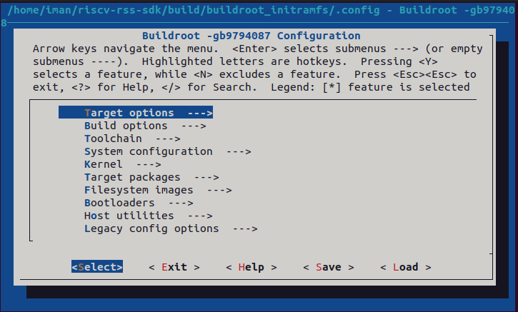

Figure 2. Config menu

In “Target options” section, enter “Target ABI” and select the “lp64” version. In “Toolchain” section, enter “Toolchain type” and select “Buildroot toolchain”. Next, enter “C library” and choose “glibc” (stay in “Toolchain” tab). Again in “Toolchain” section, enter “Kernel Headers” and choose “5.15.x” version. Then go to “System configuration” section, enable “Enable root login with password” and set a password in “Root password”. Exit the menu and save the changes, finally compile the Linux on simulator with the following command:

$ make

The compilation takes a huge time, after completed, you’ll see a Linux terminal (It’s not your system terminal). Login with root and the password you set in configuration.

# Step 8: Test the compiled Linux

To test the system, create a directory and use the “ls” command to view the directory. If the directory is created successfully, it indicates that the system is functioning properly.

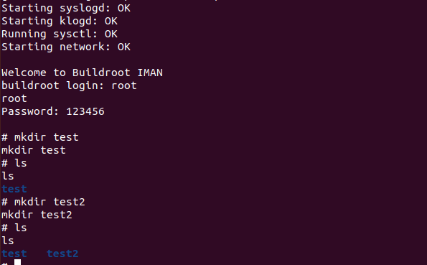

Figure 3. Test compiled Linux on simulator

# Appendix

* **Buildroot**: Buildroot is a set of [Makefiles](https://en.wikipedia.org/wiki/Makefile" \o "Makefile) and [patches](https://en.wikipedia.org/wiki/Patch_(Unix)) that simplifies and automates the process of building a complete and bootable [Linux](https://en.wikipedia.org/wiki/Linux) environment for an [embedded system](https://en.wikipedia.org/wiki/Embedded_system), while using [cross-compilation](https://en.wikipedia.org/wiki/Cross_compiler) to allow building for multiple target platforms on a single Linux-based development system. Buildroot can automatically build the required cross-compilation [toolchain](https://en.wikipedia.org/wiki/Toolchain), create a [root file system](https://en.wikipedia.org/wiki/Root_file_system), compile a [Linux kernel](https://en.wikipedia.org/wiki/Linux_kernel) image, and generate a [boot loader](https://en.wikipedia.org/wiki/Boot_loader) for the targeted embedded system, or it can perform any independent combination of these steps. For example, an already installed cross-compilation toolchain can be used independently, while Buildroot only creates the root file system.

Buildroot is primarily intended to be used with small or embedded systems based on various [computer architectures](https://en.wikipedia.org/wiki/Computer_architectures) and [instruction set architectures](https://en.wikipedia.org/wiki/Instruction_set_architecture) (ISAs), including [x86](https://en.wikipedia.org/wiki/X86), [ARM](https://en.wikipedia.org/wiki/ARM_architecture), [MIPS](https://en.wikipedia.org/wiki/MIPS_architecture) and [PowerPC](https://en.wikipedia.org/wiki/PowerPC).

Multiple [C standard libraries](https://en.wikipedia.org/wiki/C_standard_library) are supported as part of the toolchain, including the [GNU C Library](https://en.wikipedia.org/wiki/GNU_C_Library), [uClibc](https://en.wikipedia.org/wiki/UClibc" \o "UClibc) and [musl](https://en.wikipedia.org/wiki/Musl" \o "Musl), as well as the C standard libraries that belong to various preconfigured development environments, such as those provided by [Linaro](https://en.wikipedia.org/wiki/Linaro" \o "Linaro). Buildroot's build configuration system internally uses [Kconfig](https://en.wikipedia.org/wiki/Kconfig" \o "Kconfig), which provides features such as a menu-driven interface, handling of [dependencies](https://en.wikipedia.org/wiki/Dependency_(computer_science)), and [contextual help](https://en.wikipedia.org/wiki/Contextual_help); Kconfig is also used by the Linux kernel for its source-level configuration.

* **Busybox**: BusyBox is a [software suite](https://en.wikipedia.org/wiki/Software_suite) that provides several [Unix utilities](https://en.wikipedia.org/wiki/List_of_Unix_commands) in a single [executable file](https://en.wikipedia.org/wiki/Executable_file). It runs in a variety of [POSIX](https://en.wikipedia.org/wiki/POSIX) environments such as [Linux](https://en.wikipedia.org/wiki/Linux), [Android](https://en.wikipedia.org/wiki/Android_(operating_system)), and [FreeBSD](https://en.wikipedia.org/wiki/FreeBSD), although many of the tools it provides are designed to work with interfaces provided by the [Linux kernel](https://en.wikipedia.org/wiki/Linux_kernel). It was specifically created for embedded operating systems with very limited resources.

# References

[1] [https://en.wikipedia.org/wiki/Buildroot](https://en.wikipedia.org/wiki/Buildroot%23:~:text=Buildroot%20can%20automatically%20build%20the,independent%20combination%20of%20these%20steps.)

[2] [https://en.wikipedia.org/wiki/BusyBox](https://en.wikipedia.org/wiki/BusyBox#:~:text=Article%20Talk,provided%20by%20the%20Linux%20kernel.)

1. API stands for **application programming interface**, which is a set of definitions and protocols for building and integrating application software.